|  |  |
| --- | --- |
| Course Name | ITD 2313 – Script Programming |
| Instructor | <Michael Schnell> |
| Student Name | <Camden Stone> |
| Due date | <11/8/2020> |
| Grade | <grade earned here> |
| Grading Comments | <instructor comments here> |

Scripting Project Week 9

#5

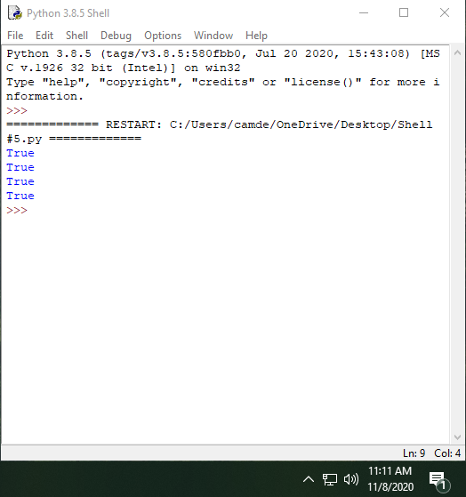

#8

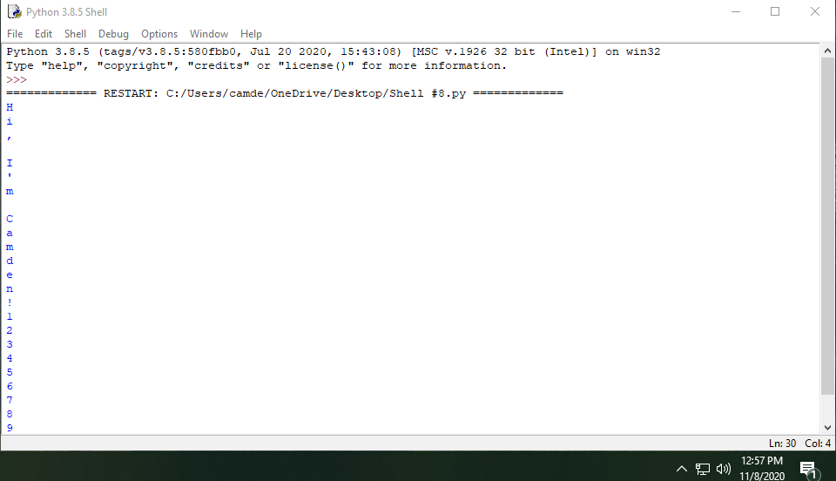

#9

